Loan Origination System (LOS)

TABLE OF CONTENTS
Page
1. Executive Summary: 2
2. Problem Statement: 2
3. Objectives: 2
4. Proposed Software Key Features: 2
5. Scope of Work: 5
6. High level Technical Design: 6
7. Proposed Technology Architecture: 7
8. Technology Stack: 7

Executive Summary:
The Loan Management Solution for banking is a comprehensive, end-to-end platform designed to streamline the entire loan lifecycle—from application and approval to disbursement. This solution aims to address the challenges faced by financial institutions in managing a large volume of loans while ensuring operational efficiency, regulatory compliance, and enhanced customer experience.

Problem Statement:
- Loan/Card origination, approval, and servicing are done manually, which causes delays, errors, and inefficiencies in disbursing loans and tracking repayments.
- Customers experience delays in loan approval, struggle to track loan status, and find it difficult to manage repayments, leading to frustration.
- It’s hard to generate accurate and timely reports on loan performance, overdue payments, and portfolio health.

Objectives:
- Reduce manual tasks and speed up loan approval, servicing, and repayment to eliminate errors and delays.
- Improve transparency and efficiency
- Centralize data for accurate, real-time information of loan.
- Offer an easy-to-use platform for customers to track loan status.
- Offer real-time insights and reports to monitor loan performance and support decision-making
- Parallel processing of loan application documents
- Eliminates redundant data entry

Proposed Software Key Features:
Customer Requisition:
- Customer request for loan at Branch level.
- Branch user entry basic info and send it to the Branch Officers Credit Committee team for approval.
Branch Officers Credit Committee (BOCC):
- Loan Request review at Branch Level Branch Officers Credit Committee (BOCC) team and Final approval by Branch Manager.
- Generate BOCC minutes of meeting report with user signature.
Initiation:
- Loan /Card data Entry at any source.
- Customer Information:
- Personal Information
- Family Information(Parent Information / Spouse Information)
- Employment Information(Professional Information/ Primary Business Details/Second line Business Details)
- Contact Information
- Financial Information(Income/ Expenditure)
- Liability Information
- Asset, Liability, Net worth
- Guarantor Information
- Contact Point Verification
- Bank Relationship Information
- Reference Information
- Particulars of Security Info
- KYC
- Special Conditions Info
- Existing Loan Performance
- Branch Loan Position
- Branch Recommendation
- Multiple Documents attachment facility.
- AES algorithm-based encryption method for document security.
- After initiation user will forward it to next user based on Business flow.
Branch Credit Analyst:
- Will scrutinize all the information of customer.
- Create DBR, CIB, CPV at head office level.
- After reviewing all info, if everything seems ok then forward it to the next level user Branch Credit head or if not ok then back it to Initiation user for given further information.
Contact Point Verification at Branch Level:
- User will verify all the provided information in branch level.
- Will generate Contact Point Verification Report.
Branch Credit Head:
- Will scrutinize all the information of customer.
- Forward to the next user.
Branch Manager:
- Loan Info Review at Branch Manager.
- Generate Branch Proposal with auto user signature capturing
- Loan Request Forward to Head Office Central Loan Division.
Head Office Central Loan Division:
- Head Office Central Loan Division Review the case and pass it to Credit Division for Analysis.
Supervisor:
- Supervisor review the case and pass it to Credit Analyst for further analysis.
Credit Analyst:
- Credit Division review CIB, CPV and further assessment.
- Generate Credit Memo (auto user signature capture) from the system.
- Credit Division asked further query to Initiator or other stakeholders.
Head of Retail:
- Head of Retail review the case.
- Can recommend Loan amount, tenor, interest and recommend for next step for approval.
- Based on Bank rules the approval process move forward. If required it might flow backward for further verification.
Deputy Managing Director
- Can recommend Loan amount, tenor, interest
- Can approve or decline the case
Managing Director:
- Can recommend Loan amount, tenor, interest
- Can approve or decline the case
Credit Analyst after Approval:
- Sanction Letter generate for Branch User and authentication by Head Office users.
- Once the case approved by Head of Retail / DMD/ AMD/MD then the case move to Credit Administrative Department.
Credit Administrative Department:
- Generate final Sanction letter and move to Branch
Branch After Generate Sanction Letter:
- Generate Sanction letter for customer
- Branch verifies the requirements for disbursement and prepare disbursement letter.
- Move the case to Credit Administrative Department for limit loading.
Credit Administrative Department:
- Finally loading the limit.
- Move to the Branch.
Branch after Limit Loading:
- Branch can store all inventory information of physical documents.
Others:
- Facing required CBS Data.
- Auto signature
- NID Auto Capture
- Manage workflow as per business needs.
- Manage all documents and internal notes.
- Automated credit scoring system to get eligible customer
- Dedupe Checking
- TAT report
- Branch Wise Loan Status
- Overall Loan Status
- Advance Customer Search
- Generate Report:
  - BOCC note
  - Branch Proposal
  - Contact Point Verification Report
  - Head office Credit Proposal Memo
  - Approval Note
  - Sanction Letter
  - Loan Proposal Letter
  - BRTA Letter
  - Car Loan Letter
  - Limit Loading Report
  - Document Checklist
Integration:
- Core Banking System
- Card Management System
- FTP server
- Email
- SMS
- AML
- Other internal Software

Scope of Work:
The LMS project will encompass the following components:
1.1. Frontend Development
- Responsive Web Application: Built using Thymeleaf, jQuery, and JavaScript.
1.2. Backend Development
- Microservice Architecture: The backend will follow a microservices approach for modularity and scalability.
- Spring Boot: Used for building RESTful web services.
1.3. Database Design
- MySQL: A relational database will be used to store and manage data.
1.4. DevOps & Infrastructure
- Server Management: Managing deployment and database operations on the server.
- CI/CD: Continuous integration and deployment pipeline setup for smooth releases.
1.5. Security & Compliance
- Authentication: Spring Security will be used for user authentication and access control.
- Data Encryption: No data encryption mechanism is implemented as part of the current scope.

High level Technical Design:
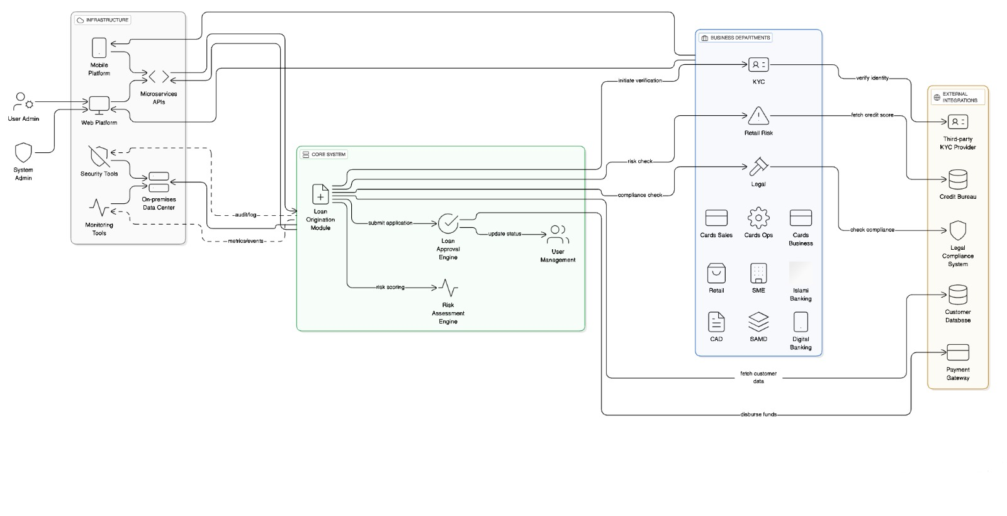Figure: Application Architecture in Details with Traffic Flow

Proposed Technology Architecture:
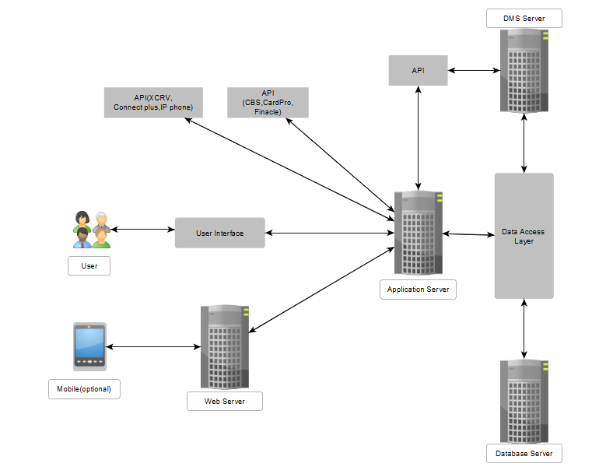
Figure: Proposed Technology Architecture

Category | Tools/Technologies
Frontend | thyme leaf, jQuery, JavaScript
Backend | Java, Spring Boot
Database | MySQL
DMS | LogicalDOC
Reporting | Jasper Report

Technology Stack:

